**Lab 8: Phasor Circuit Analysis**

**Objective:**

Introduce sinusoidal steady state analysis and show that Kirchhoff’s laws apply to phasors in the frequency domain.

**Equipment and Components:**

* Multisim or any SPICE simulator
* Breadboard
* Oscilloscope
* Function Generator
* Resistors: 510 Ω, 1 kΩ
* Capacitor: 1µF

**Preliminary:**

1. Calculate the node voltages V2 and V3 for a 5 V amplitude, 300 Hz sinusoidal source as shown in Fig. 8.1.
2. Calculate the currents I1, I2, and I3.
3. Create the circuit on Multisim or any SPICE simulator. Use the transient analysis (time domain) to simulate the circuit. Set the start time (TSTART = 0) and the stop time (TSTOP) such that it will display 10 complete cycles.
4. For the following, ignore the 1st cycle of data since it will include transients until it reaches the steady state.

Treating the supply as zero phase, calculate the phasor form of I1, I2, I3, V1, V2, and V3.

***Hint:*** *Use cursors to calculate time difference between zero crossing of Vac and other voltages; this would be the time shift.*

To convert the time shift (t) to degrees (ϕ), use the following formula:

 …………..………….…………………(1)

1. Include plots of all currents and voltages in your lab book.

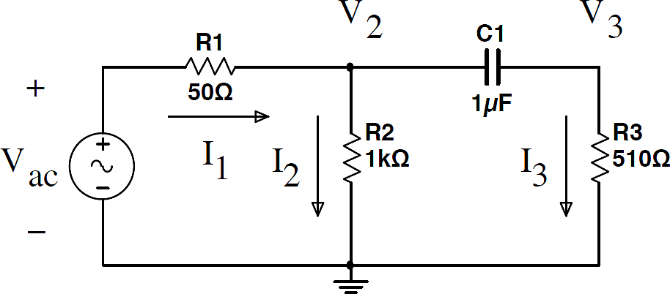

Fig. 8.1: AC Circuit to be analyzed

(note that the internal resistance of the voltage source = R1=50 Ω)

**Procedure:**

1. Create the circuit as shown in Fig. 8.1. Note that the 50 Ω resistor represents the function generator’s internal resistance and you do not need to use a separate resistor for it in the experiment.
2. Prior to connecting the function generator to the circuit, carefully check all the connections and make sure that you have verified (using an oscilloscope) the 5 V, 300 Hz sinusoidal waveform as the input signal.
3. Use the oscilloscope to measure the magnitude and phase of V2 and V3. Assume V2 is at zero phase (since you cannot access the Vac). The phase in radians is determined from ϕ= - ωτ; where ω = 2πf and τ is the time shift relative to V2. Expand the time scale of the oscilloscope trace so that an accurate measurement of τ can be made.
4. Calculate I2, and I3 from the measurements of V2 and V3.
5. Calculate I1 using KCL at node V2. e. Calculate VR1 from I1.
6. Calculate Vac. using KVL.

**Conclusion:**

Compare your preliminary calculations to your simulation and measurements, display all values in a table including % errors from calculated values, and give plausible reasons for the discrepancies.